**How to manually install failed patches**

1. On the server with the failed updates , go to the search button on the bottom left corner of the task bar, search for windows update



1. Select “Windows Update Settings”

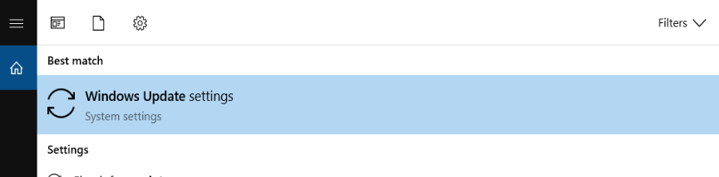

Then Next screen will tell you all the update failures

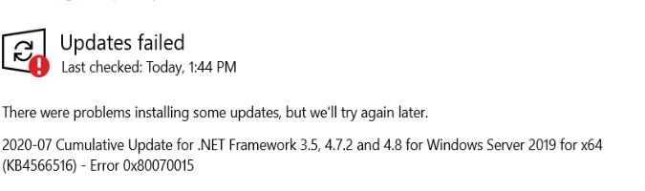

1. HighLight the missing patch, copy and go to catalog.update.microsoft.com
2. In the upper right corner search for the kb that you need



1. Download file and then transfer it to the appropriate server



1. Once patches are uploaded to your vm, Open command prompt as administrator and run the following to install

Wsua (path to udpate file) to do an interactive install

Or

Wusa (path to update) --/quiet /norestart for silent install

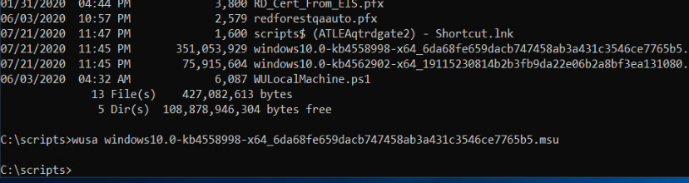

1. To install a patch that comes in a .cab format do the following
2. Extract it to a folder like c:\temp
3. Run DISM.EXE Online /Add-package /packagepath: (Path to .cab package)